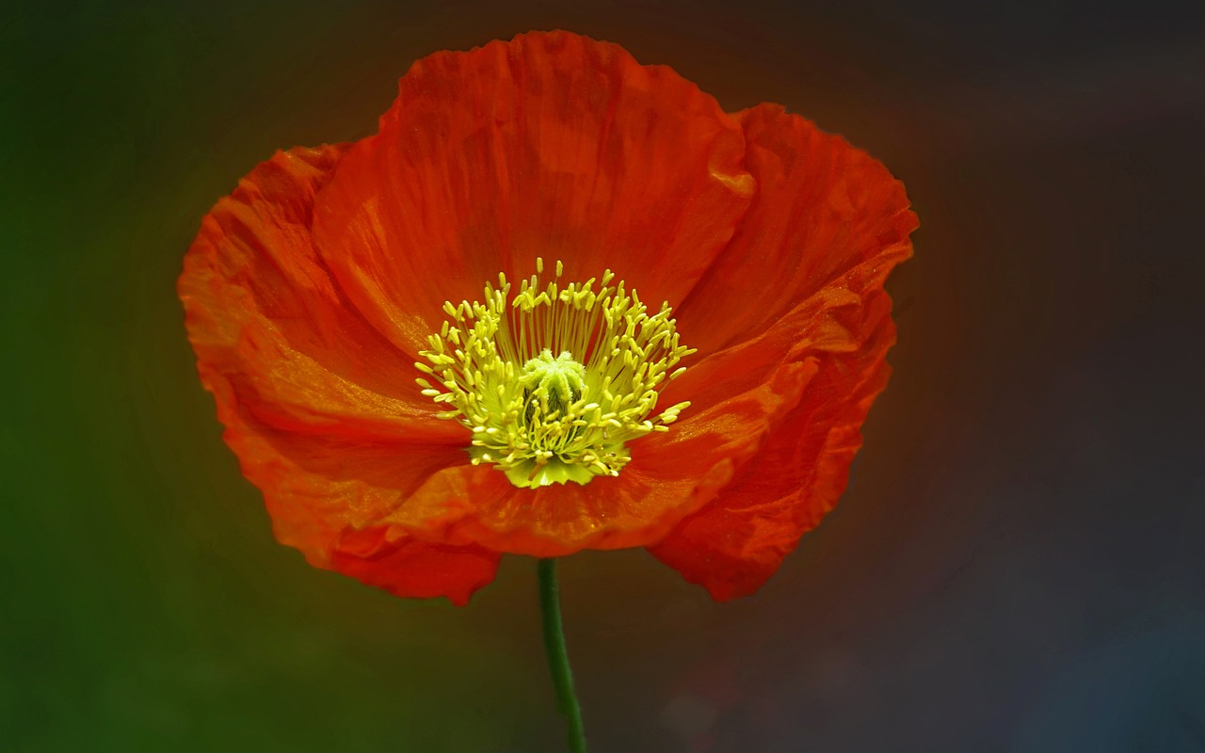

A Letter of Acknowledgement and Thanks
to All U.S. Veterans This Veterans Day

Dear U.S. veterans from all branches of military service,

A hero is defined as “a person noted for feats of courage or nobility of purpose, especially one who has risked or sacrificed his or her life.”

And that’s what all our veterans are, heroes. Regardless of which branch of service you served in, we thank you for being brave, dedicated, and making the sacrifices you did for our country.

For keeping us safe.

For keeping us free.

So often, especially in today’s social and political climate, many of us take the freedoms we have for granted and don’t even think about why we continue to have these freedoms.

It is only because of the selflessness of you all, who gave up your time, your comforts, and for many who didn’t make it home, your lives to something much bigger than yourself. Most often for little acknowledgement, little pay, and little reward, to a post-service civilian life fraught with extra everyday challenges.

While most of us will never know or understand the sacrifices you’ve made and internal battles you still may face because of your service, we recognize that many of you experienced combat and the horrors that go along with it.

We recognize that many of you still carry that damage and pain, whether physical, emotional, or moral, and many of you don’t feel like heroes at all. It can be extremely difficult to reconcile what you witnessed or the things you had to do while in combat.

We understand and want you to know you are not alone in your fight.

It takes a special kind of person to give up so much and live with such consequences for people you don’t even know and will never meet.

That is a true hero.

When someone willingly sacrifices their own wants, needs, and desires for the benefit, safety, and betterment of others, that will always make you a hero.

For those who served during peace time, your service was still invaluable to the country you swore to protect, and we thank you, too, for your time and dedication. You are also the reason we remain at peace and able to provide for our families and get to hug our children every night.

And to all your families who gave up their time with you, the innumerable memories they weren’t able to make with you, to your children who had to grow up without your presence, so you could protect and serve us, you have no idea what your truly sacrifices means.

Know you are the brave, the selfless, the honorable, and we thank you from the bottom of our hearts for keeping us safe and free. May you know peace within you and many blessings throughout life.

Sincerely,

Ahndrea L. Blue
Making A Difference Foundation

This Veterans Day, Making A Difference Foundation would like to thank every veteran who selflessly and honorably served our country. We wish we could thank each one of you personally. This letter to you we hope will suffice.

